Please provide detailed solutions to these three problems.
- Develop a set of tables similar to Table 5.3 from the textbook for GF(4) with Modulo (x2 + x + 1).
- Determine the multiplicative inverse of (x³ + x + 1) in GF(2^{﻿4}﻿) with m(x) = x^{﻿4}﻿ + x + 1.
- Develop a table similar to Table 5.5 from the textbook for GF(2﻿4﻿) with m(x) = x﻿4﻿ + x + 1.

Table 5.3
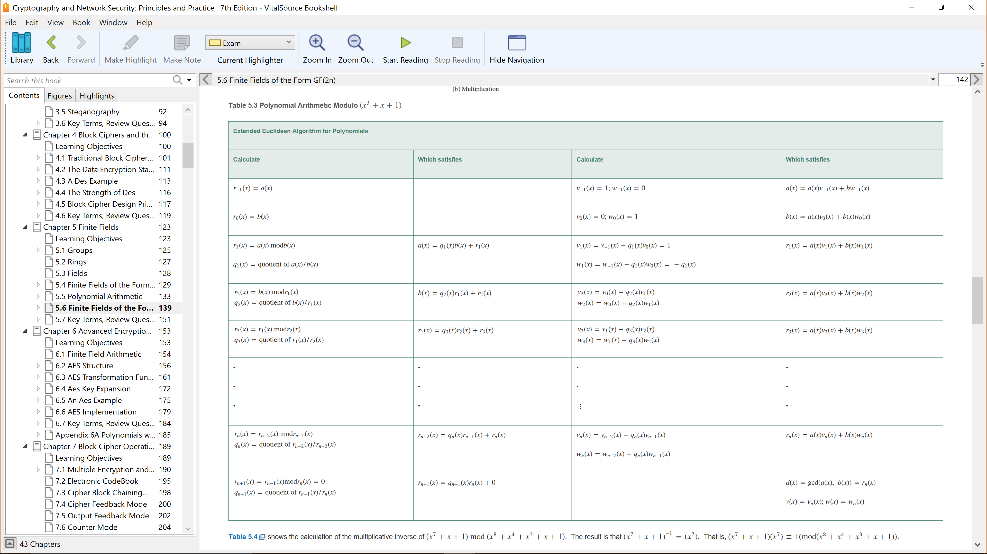
Table 5.5
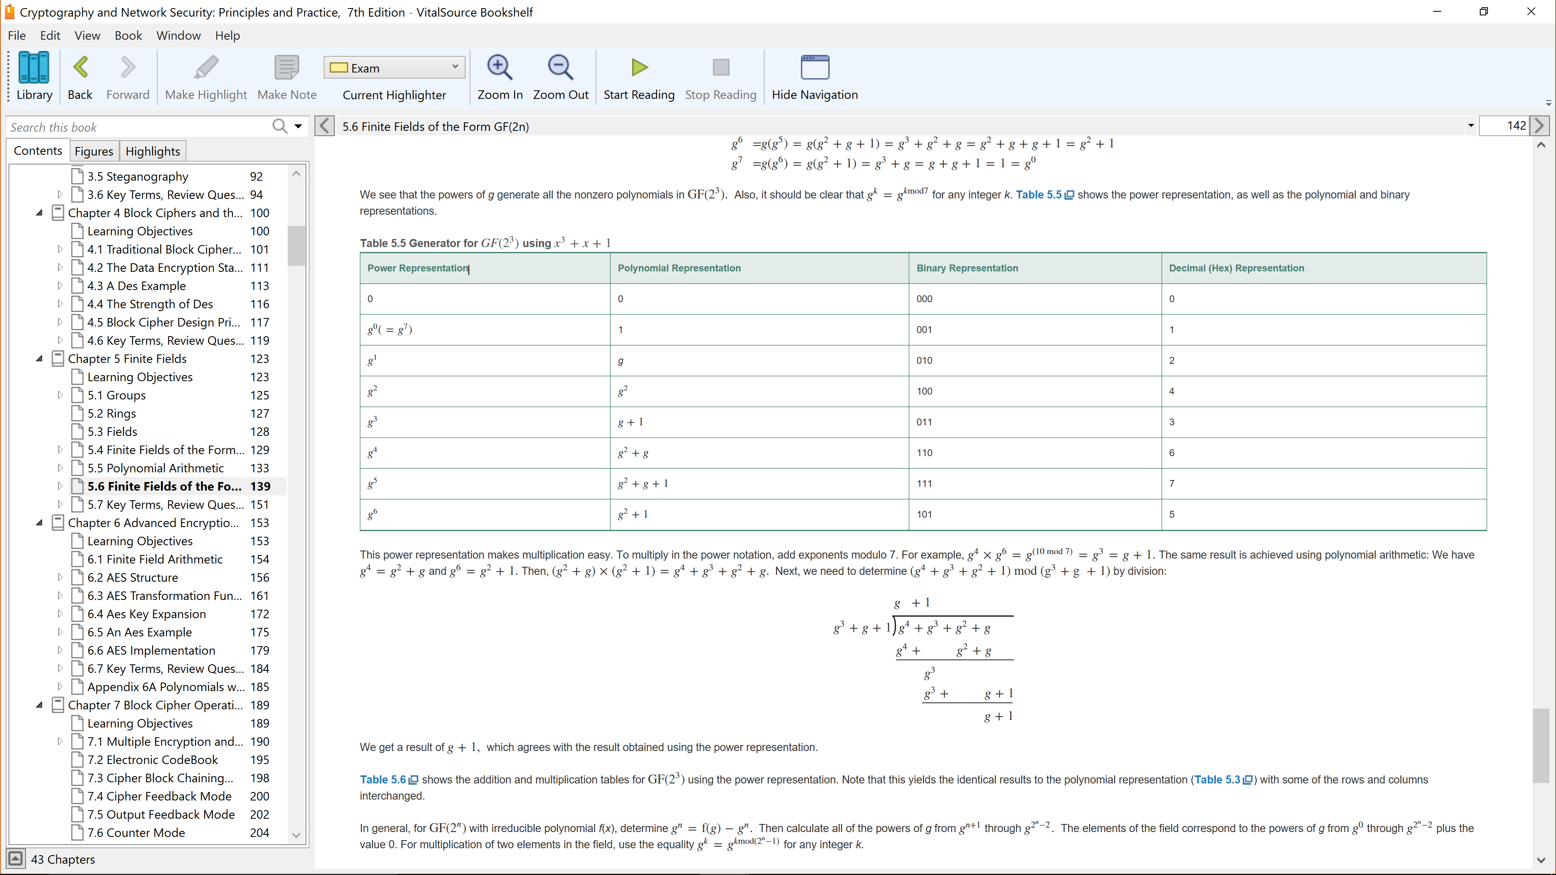

5.1 For the group S n of all permutations of n distinct symbols,
- what is the number of elements in S n ?
+ | a | b
a | a | b
b | a | b
x | a | b
a | a | a
b | b | b
5.3 Consider the set S={a,b} with addition and multiplication defined by the following tables.

Is S a ring? Justify your answer.

